Catherine Review

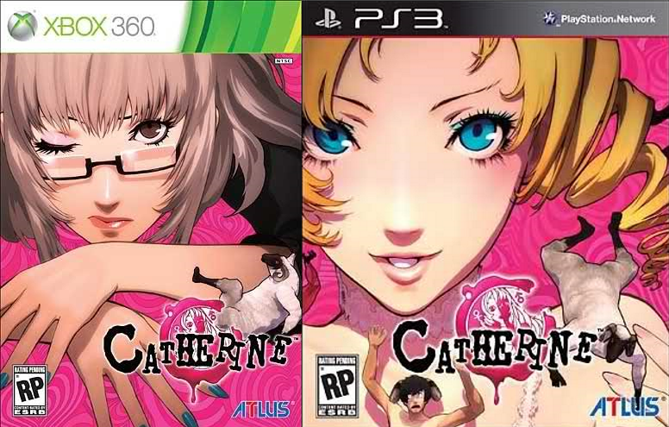

|  |
| --- |
| **Platform(s):** PS3, Xbox 360  **Developer:** Deep Silver  **Publisher:** Atlus  **Year of Release:** 2011 |

The fact that there are only 2 playable locations contributes to Catherine feeling as though it exists on a small scale. Yet this is a video game whose ambition has lead it to telling a different and more mature story than is typically seen in the medium, through the lens of a conflicted man dealing with his anxiety over cheating on his girlfriend and deciding the direction his life should take. Despite a poorly implemented camera system and a difficult puzzle sections, it manages to be an exciting and engaging game. Unfortunately it fails in the execution of its philosophical tone by implementing a binary moral choice system which creates a clear incentive for players to make consistent choices over the correct ones for them, thereby breaking the purpose of the system itself.

Catherine goes against the typical video game convention in that its central focus is on an ongoing relationship as opposed to the legions of the games that focus on the grandiosity of saving the world or preserving the status quo for some global organization or exacting vengeance on a powerful adversary. Yet despite a seemingly low-key plot, whose conflict really centers around 3 characters, it manages to find ambition within the mundanity of its subject matter using its puzzle sections and over-the-top anime art style to inject it with a greater sense of panache and scale than one would naively think could come from what amounts a domestic dispute.

The player steps into the shoes of Vincent Brooks, a 32 year old engineer in a long-term relationship with a woman named Katherine. Just as Vincent begins feeling pressured by her when she hints at the prospects of marriage and parenthood, the woman of his dreams, named Catherine, comes barreling into his life to upset his established order. After a drunken night Vincent wakes up to find Catherine in his bed, prompting his anxiety over the situation to boil over and his nightmares to begin.

In terms of design this is a puzzle game with some life simulator elements. The gameplay is split between the real world, in which Vincent frequents his favorite bar, and the dream world in which he climbs increasingly complex towers of blocks which he must escape from by night’s end.

The life simulator system of the game takes place in Vincent’s favorite bar, the Stray Sheep. Here players can guide him to talking to the other patrons, texting one of his two ladies, drinking or playing a mini-game called Rapunzel. This system does not have the depth other life simulators, like The Sims, as the number of activities and their impact is limited.It does, however, function well as down-time after the excitement of the nightmare stages. Though players who are not interested in learning more about the supporting cast will be disappointed by its inclusion.

In terms of the mechanics Catherine’s core gameplay centers around the nightmare stages in which the player controls Vincent as he attempts to climb new towers of blocks each night. Vincent starts on the bottom rung of a multi-level tower, made up of moveable blocks. The player’s role is to push and pull the blocks to form staircases and climb towards the exit at the top of the tower. Success will mean Vincent’s survival for the night. The basic mechanics are easy to grasp but the game quickly presents complexity by introducing elements which affect player thought both directly and indirectly.

Directly it introduces multiple block types and monsters at the end of each night which function as a kind of boss battle for the player to deal with. The monsters themselves are all horrific representations of Vincent’s foremost anxiety at the time and try to stop him from escaping the nightmare by knocking him off platforms, destroying blocks and trying to kill him directly.

In boss battles the player has to account for an external entity that will attack them and alter the tower as they are climbing it. Having bosses change the stage with their attack patterns makes encountering them a kind of intellectual-mad-dash where the player’s ability to avoid those attacks, adjust to the changes and still climb the tower are tested. When players are able to accomplish this it can feel both exhilarating and satisfying to escape using a combination of one’s wits and reflexes.

As Catherine is a puzzle-game, gradually altering the factors that the player must keep track of will force them to calculate in a different way. It is necessary for the puzzles to evolve over time for the game to retain some challenge. This is a transition that must be handled with care. For the most part Catherine handles this well. Each block type is introduced in its own stage and bosses sometimes telegraph their attacks just before they happen so as to give the player a chance to avoid them.

It is the introduction of the indirect gameplay features that push Catherine’s puzzles into the territory of difficult and suggest more about the game’s expectations from the player. These include: the last level of blocks falling away at timed intervals, a score for each stage, an ever-decreasing combo meter -which resets when new level of blocks is reached- and items which help the player change the environment. The combo meter and score work together, as the combo multiplies the score thus creating an incentive for the player to move to new levels and to do it quickly. Adding to this the game grades the player after each tower based on their score.

The game relieves the time pressure by implementing an ‘undo’ feature which allows players to undo their previous block move and reset all timed elements to when that block was moved. This can lend more of a trial-and-error feel to the interaction but provides help for players who are struggling with the game’s puzzles and manages to boost the accessibility of the gameplay.

Together the timed elements and score imbue the game with a feeling of haste and contribute to the overarching sense that it wants the player to make decisions quickly and conclusively. They also allow the game to conform to the ‘action-puzzle’ game standard in that Catherine gives the player a puzzle to solve under time pressure and also provides a means of relieving that pressure.

Overall the gameplay system can be difficult, especially when required to think under pressure, yet when it works the excitement of completing the challenges it presents is worth experiencing for any fan of puzzle games.

The fundamental ideas Catherine concerns itself with are: its protagonist’s journey to maturity and the question of whether men and women can truly be happy together. It addresses these through the narrative and the choice system.

In terms of narrative structure Catherine’s closest contemporary is found outside the medium of video games in the movie Scott Pilgrim vs. the World. Both film and game focus on the plight of a young man, forced to grow up quickly as he faces a series of trials brought on as a result of being in a relationship while borrowing an aesthetic from another medium. The game, like the film, ultimately boils down to a maturity tale with the relationship drama existing on separate level. The difference is that Pilgrim is an examination of relationships in the 21st century while Catherine is a meditation on whether men and woman can coexist in relationships at all. Each of the game’s leading ladies represent a particular lifestyle which the player must choose to pursue and in so doing, choose which philosophy they believe in. Whether it’s the slightly controlling, mundane yet stable Katherine or the crazed, exciting, live-the-moment Catherine, the game asks the player to make this choice for Vincent once he has grown up enough to realize that it needs to be made.

The game furthers its thematic content and leverages off of the advantages afforded to it by the medium it occupies by using player choice. This choice boils down to making decisions for Vincent regarding his love life and answering questions on their own philosophy towards relationships. Moreover in each nightmare the player will help him answer questions in a confessional.

The confessional questions are good idea in theory: getting the player to render their opinion on the subject of relationships and tracking that to have it influence the way the story unfolds conforms well to a choice-based design. It also utilizes the medium of video games very well by linking gameplay and narrative together.

There is a problem with the questions the game asks the player in that they [the questions] have an inconsistent quality to them, ranging from the thematically relevant: “Which is more cheating: an emotional affair or a [physical] fling?” to the silly “You must kiss one of these. Choose: A cephalopod-like alien or a beautiful corpse.” This kind of logical inconsistency drags the value of this system down and the game alongside it.

Like Mass Effect and Infamous before it, Catherine uses a binary moral choice system, where the player is able to make decisions which affect a morality meter acting as a scale veering between ‘Order’ on the one side to ‘Chaos’ on the other extreme. This is helps replay value while being a fundamentally problematic way of approaching morality. Typically in games the binary moral choice system rewards players who make decisions which are thematically consistent with one of its two extremes. In this regard Catherine fairs no differently as almost every decision the player makes outside of the tower-climbing gameplay is evaluated and influences the morality meter. Taking into account the game’s 8 endings, the most positive end states for Vincent are the ones in which the morality meter is further towards the extremes. This creates a clear incentive for players to make consistent decisions over those which are right for them at every instance, removing ambiguity and judging said players in the same breath. In a game which wants to be about moral quandaries and players making up their own minds about a specific issue, the system becomes problematic and begins to undermine the point of having a philosophical tone in the first place.

Despite the problems it causes for player behavior, the binary moral choice system does actually support the core theme of maturity through the emphasis on consistent decisions. It reserves the most positive endings for those who decide what they want and take steps towards reaching that. When coupled with the emphasis on speed and conclusive decision making from the gameplay, it becomes clear that Catherine just wants players to make a decision about the direction they want to take in life and to do it quickly. The one thing it appears to despise is what Vincent is in the opening, pusillanimous and immature. It seems to not care for people who waste time in indecision and half-hearted effort and as such it punishes them for only going half-way towards their goals. Whether the player chooses Catherine (Chaos), Katherine (Order) or neither, the game just wants the player to choose and go at it with everything they have. This is, what it seems to posit, is true maturity and ultimately what it expects the player, through Vincent, to learn.

The art design imbues another layer of meaning into the game by establishing the uncanny tone of the game while managing to further the core theme of maturity. The overall the nightmare stages have an element of otherworldliness to them. The landing area of each nightmare stage resembles a church with the actual tower puzzles being accessed through a confessional which doubles as an elevator. Moreover the other men who appear in Vincent’s dreams are all represented as sheep while Vincent himself grows a pair of horns. The supernatural feeling is also advanced by the stages typically being associated with the afterlife and judgement. Particularly the earlier levels are linked with death and Hell with the opening stage taking place in an area called the Cemetery and second in The Prison of Despair. As the player progress through nightmares, the settings change to a courthouse and ultimately move towards being associated with Heaven instead with the finals levels playing out in The Cathedral and The Empireo to represent Vincent’s journey to maturity. From this, purely aesthetic, perspective the game can be taken as an ascent out of Hell.

Catherine’s story can be taken as a climb to maturity. The game advances its protagonist to the point where he must make a choice and then defaults to player behavior to make that decision. The choice-system itself, however, doesn’t work the way the game intends it to and actually ends up undermining independent thought by creating a system which incentivizes consistency. Taken as a whole the game has an interesting and exciting, if not niche, appeal to it. Catherine is an atypical entry into the medium of video games and is certainly worth experiencing for anyone looking for something different.

**Paul Cupido**